Q1) Write a program to calculate f(x) = sin(x) where x is in degree.

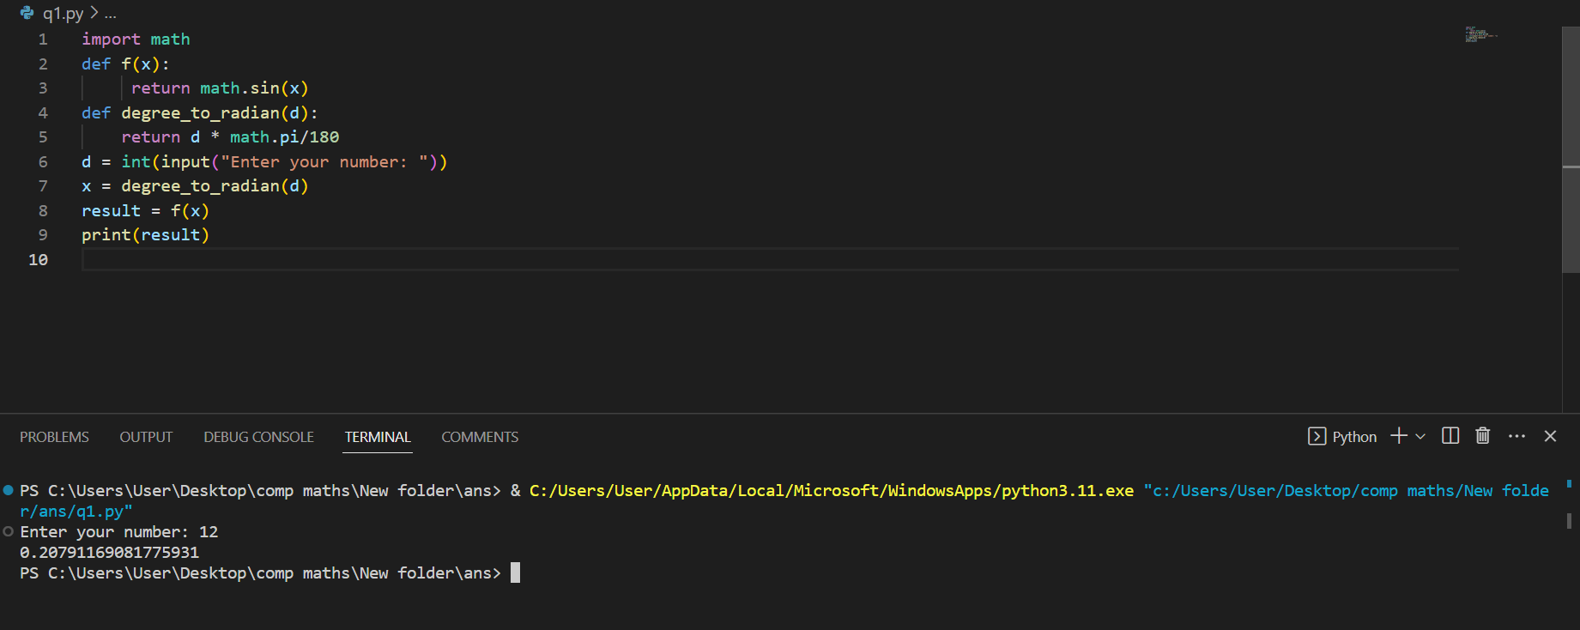

Q2) Create a function that accepts a list of numbers and returns the sum of elements on the list.

For example:

If a list **[1, 3, 6, 8, 12]** is passed as an argument to a function, the function should return a value of **30**.

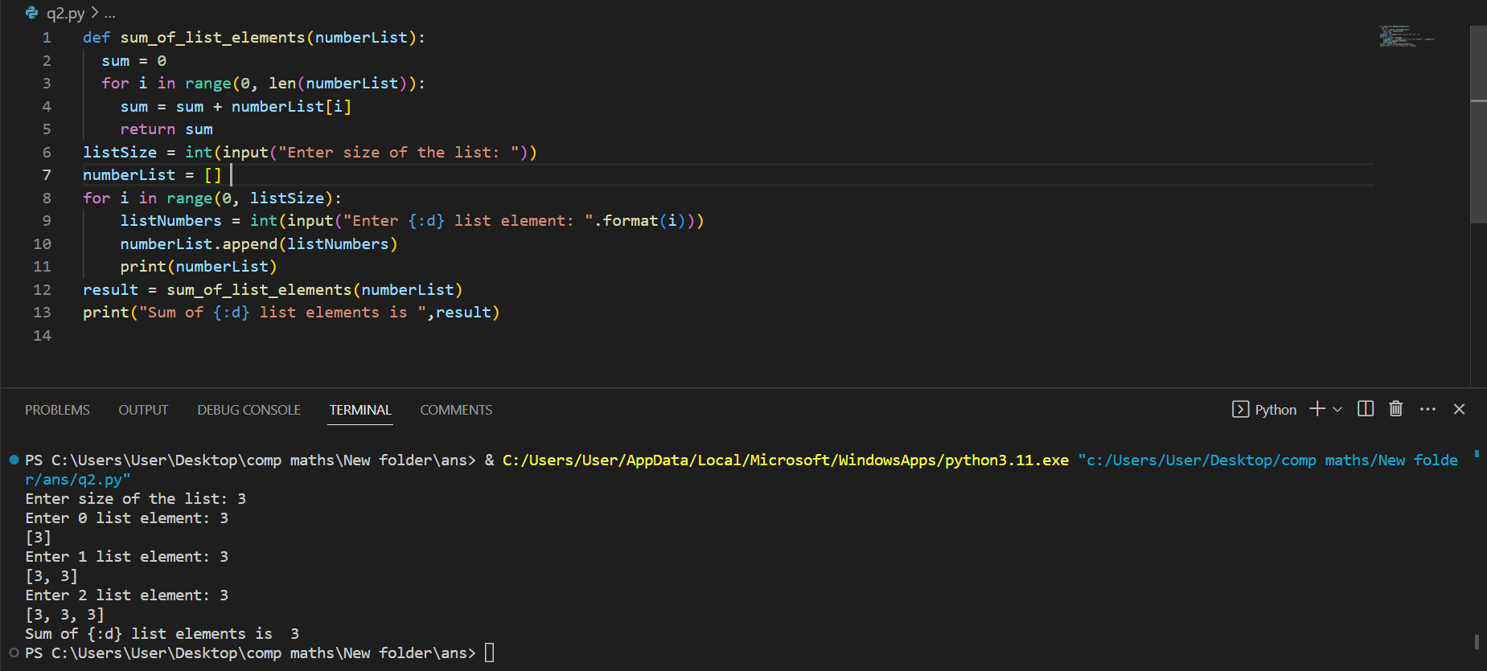

Q3) Write a program to calculate the sum of digit of a number using fuction.

Q4) Write a program to calculate the smallest divisor of a number using function. for example: samllest divisor of 15 is 3.

Q5) Write a program to check a given number is perfect number or not using function.

A positive integer is called a perfect number if it is equal to the sum of all of its divisors, including 1 but excluding the number itself. For example, 6 = 1 + 2 + 3.

Q6) Write a function that takes two integers m and n as arguments and prints out an **m×n** box consisting of asterisks. for example: **rectangle(3,4)** should print following output:

* * * *

* * * *

* * * *

Q7) Write a python program to create a matrix of dimensions m x n without using any additional libraries and display the values.

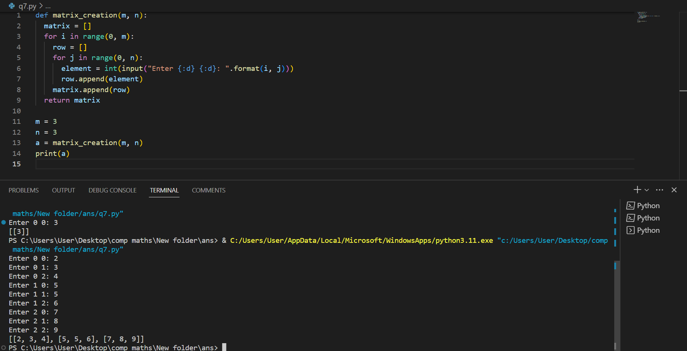

Q8) Write a program for addition of two matrices.

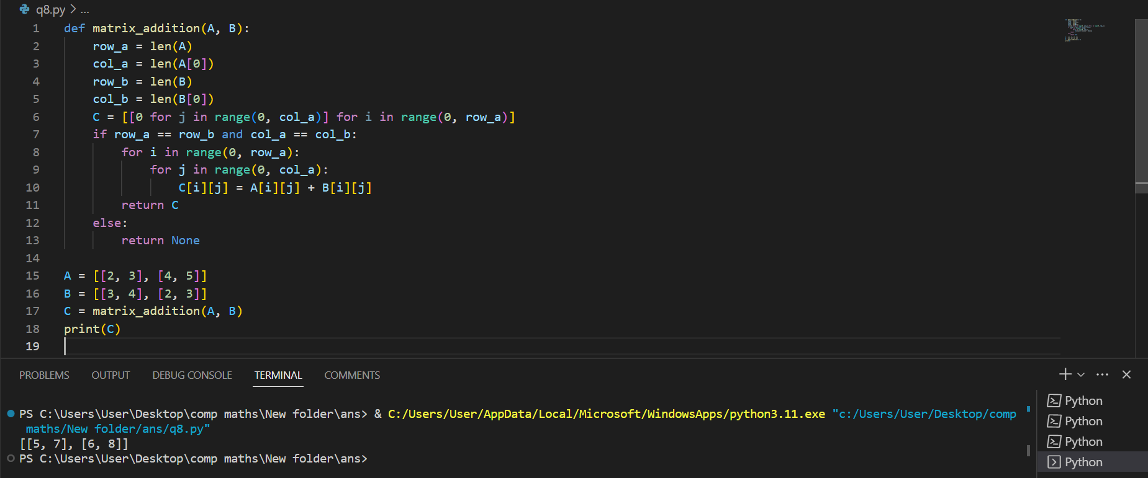

Q9) Write a program to identify the given matrix is diagonal matrix or not.

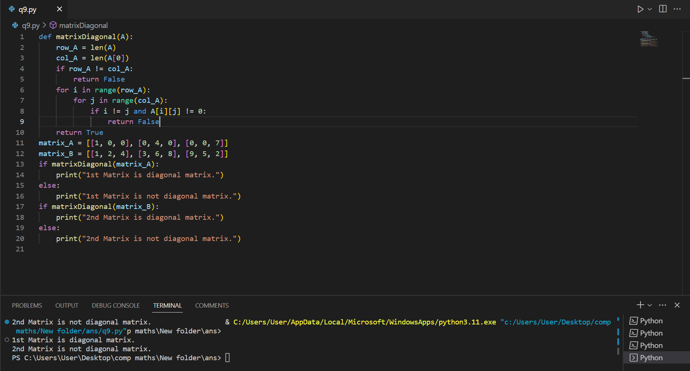

[Colab paid products](https://colab.research.google.com/signup?utm_source=footer&utm_medium=link&utm_campaign=footer_links) - [Cancel contracts here](https://colab.research.google.com/cancel-subscription)

**

10

s

completed at 2:16 PM